A

MINOR PROJECT SYNOPSIS

BhagvadMood Journal
(An AI-Powered Mental Health Platform Integrating NLP and Vedic Wisdom for Emotional Well-being)


Submitted in partial fulfilment of the requirements for the award of the degree of B.Tech in Computer Science and Engineering
Submitted By :

Chahat Modi (Registration No. : 23BCON0775)
Under the Supervision of Dr. Jitender Kumar (Assistant Professor)
Department of Computer Science & Engineering

Session: 2026-27 JECRC University, Jaipur

TABLE OF CONTENTS

S. No. Content Page No.
- Introduction 1-2
  - Problem Statement
  - Overview
  - Objective
  - Solution
- Feasibility Study 3-4
  - Need
    - Target Audience
  - Significance
  - Feasibility
- Project Features 5-10
- Tools, Technologies and System Requirements 11-12
  - Tools and Technologies Used
  - Hardware Requirements
  - Software Requirement
  - Functional Requirements
  - Non Functional Requirements

Work Plan and Methodology 13
  - Methodology
  - Project Timeline
  - Roles and Responsibilities
- Conclusion 14

INTRODUCTION

INTRODUCTION

Problem Statement
Many individuals face significant challenges in identifying, tracking, and effectively reflecting on their emotional states during daily life. Current digital journaling tools often lack the necessary personalization and cultural relevance, leading to low user engagement and limited emotional growth. Furthermore, existing applications frequently fail to detect critical crisis moments or provide specialized support for specific demographics, such as women’s health tracking. A research gap identified through the study of over five academic papers highlights that most sentiment analysis models are trained on social media data rather than private entries, reducing their accuracy in detecting genuine depressive patterns.

Overview

The BhagvadMood Journal (also known as SarathiApp) is a comprehensive, full-stack, emotion-aware spiritual companion designed to bridge the gap between modern wellness technology and ancient Vedic wisdom. Developed as an offline desktop application, it provides a secure and private environment for users to document their thoughts without the privacy concerns associated with cloud-based platforms. The system functions as a holistic wellness tool that integrates mental health tracking with physical health monitoring, specifically addressing the intersection of hormonal cycles and emotional well-being.

Objectives

The primary goals of this project are:

    - To build a robust Tkinter-based desktop application for daily emotional journaling.
    - To utilize Natural Language Processing (NLP) through TextBlob to accurately classify user moods from raw text inputs.

    - To provide spiritually resonant guidance by mapping detected moods to specific Bhagavad Gita shlokas and positive cognitive reframes.

    - To implement specialized tracking for the female menstrual cycle, including symptoms, flow, and energy levels, to offer holistic health insights.
    - To enhance user engagement through gamified features like the "Spin Wheel" for motivational boosts and a structured To-Do list for task clarity.
    - To ensure data privacy through a localized MySQL database, allowing for offline statistics and entry management.

Solution

The BhagvadMood Journal provides a personalized, offline solution that uses advanced sentiment analysis to contextualize a user's emotional state. Unlike generic tools, it offers a "Safety-First" approach with hardcoded, priority regex-based crisis detection to immediately redirect users in distress to helplines. By automating the "emotion reframing" process through the lens of the Bhagavad Gita, the application offers a unique, culturally tailored support system that fosters resilience and self-reflection. The integration of physical health logs and visual mood analytics ensures a complete holistic view of the user’s well-being.

FEASIBILITY STUDY

    - Need: Many individuals struggle to identify, track, and reflect on their emotional states in daily life. While existing tools often lack personalization, offline availability, cultural relevance, and the ability to detect crisis moments during user entries which leads to low user engagement and limited emotional growth. Furthermore, there is a significant demand for specialized, culturally relevant support tailored to specific user demographics, such as integrated tracking for women's health.

Target Audience:

Students: Individuals managing academic stress who require task clarity and motivational engagement.
Professionals: Users seeking a private tool to manage work-life balance and emotional trends.
Women: Specific demographics requiring integrated tracking for physical symptoms and hormonal influences on mood.
Counsellors: Mental health professionals utilizing a dedicated dashboard to view anonymous patient histories for better context.
  - Significance: This system brings transparency to personal emotional trends, provides digital records for stakeholders, and makes spiritual support easily accessible

Feasibility:
    - Technical Feasibility: The project is developed using widely used Python libraries (Tkinter, TextBlob) and MySQL, ensuring a robust and well-documented environment for offline data management.. All required tools are freely available or low-cost.
    - Operational Feasibility: The interface is kept simple and user-friendly so that even users with basic computer knowledge (or with help from local facilitators) can operate it.

    - Economic Feasibility: As an offline, desktop-based academic project, development and deployment costs are minimal, utilizing local hardware without cloud subscription fees. It can later be hosted on free/low-cost platforms or utilized as a standalone desktop application.

PROJECT FEATURES

The system includes the following key features categorized by user roles and system capabilities:

User Roles & Registration:

Admin Module:

  - Manages overall system operations and user activities

  - Ensures database security and access control

  - Monitors platform performance and integrity

User Module:

  - Secure registration and login system

  - Categorized access for Students, Professionals, and Non-professionals

  - Personalized experience based on user type

Counselor Module:

  - Allows verified professionals to register on the platform

  - Enables interaction with users for emotional support

  - Maintains authentication and professional credibility

User Features:

AI-Powered Sentiment Analysis (USP):

  - Analyzes user-written thoughts using TextBlob

  - Classifies emotions (e.g., anxious, sad, peaceful)

  - Handles sarcasm and negation for better accuracy

Active Emotion Reframing (USP):

  - Identifies negative thought patterns

  - Suggests positive and constructive alternatives

  - Helps improve emotional mindset

Vedic Guidance Integration:

  - Maps emotions to Bhagavad Gita verses

  - Provides meaningful interpretations

  - Offers culturally relevant spiritual guidance

Integrated Period Journal (USP):

  - Tracks daily physical symptoms and flow intensity

  - Records energy levels and mood variations

  - Helps analyze hormonal impact on mental health

Gamified Motivation:

  - Includes a “Spin Wheel” feature

  - Generates random motivational messages

  - Saves messages as journal entries for later reflection

Task Clarity & Organization:

  - Provides a To-Do list feature

  - Includes time-based reminders

  - Helps users stay organized and productive

Entries Management:

  - Allows users to search past entries

  - View and analyze emotional records

  - Helps track personal growth over time

Admin & Counselor Features:

Clinical Context Dashboard:

  - Displays anonymized user journal data

  - Helps counselors understand emotional patterns

  - Supports better session preparation

Confidential Booking:

  - Secure appointment scheduling system

  - Allows approval, cancellation, and tracking

  - Ensures privacy of user data

Slot Management:

  - Enables creation of available time slots

  - Allows modification of schedules

  - Improves appointment organization

System Oversight:

  - Monitors platform usage and activities

  - Manages user and counselor accounts

  - Maintains system reliabilit

Additional System-Wide Features:

Privacy-First Offline Operation (USP):

  - Works without internet connectivity

  - Uses MySQL for local data storage

  - Ensures high data privacy and security

Data Visualization:

  - Generates pie charts for mood distribution

  - Creates graphs for physical health tracking

  - Helps users understand patterns visually

Knowledge & Resource Hub:

  - Provides self-care tips and wellness content

  - Includes health facts and book suggestions

  - Offers additional learning resources

Secure Data Export:

  - Allows export of data in CSV format

  - Helps maintain personal backups

  - Can be shared with professionals if needed

Crisis Handling:

  - Detects critical/emergency keywords using regex

  - Prioritizes sensitive entries

  - Redirects users to professional helplines

SYSTEM START / USER

ADMIN MODULE USER MODULE
COUNSELLOR MODULE

SYSTEM OVERSIGHT & MONITORING
MANAGE USERS & COUNSELLORS
SECURITY & DB CONTROL

REGISTRATION & LOGIN
PERSONALISED EXPERIENCE
USER FEATURES (CORE SYSTEM)

CORE USER FEATURES
COUNSELOR REGISTRATION

USER INTERACTION & SUPPORT

DASHBOARD & SLOTS MANAGEMENT

AI SENTIMENT ANALYSIS
EMOTION REFRAMING
VEDIC GUIDANCE PERIOD JOURNAL

GAMIFIED MOTIVATION
TO-DO REMINDERS ENTRY MANAGEMENT
DATA VISUALIZATION

SYSTEM-WIDE FEATURES

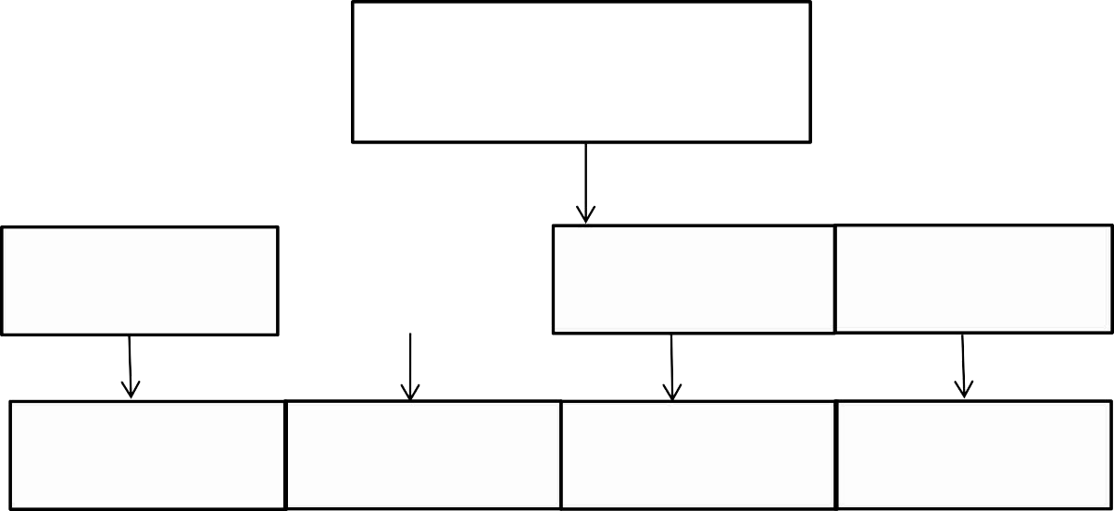
OFFLIE PRIVACY MODE
RESOURCE HUB DATA EXPERT (CSV) CRISIS HANDLING

TOOLS, TECHNOLOGIES AND SYSTEM REQUIREMENTS

Tools and Technologies Used:

    - IDE: Visual Studio Code (VS Code)

    - Frontend: Tkinter (Python).

Backend: Python 3.x (Object-Oriented Programming, Regex).

    - Natural Language Processing (NLP): TextBlob and NLTK.

    - Database: MySQL Server and XAMPP/WAMP for local management

    - Visualization: Matplotlib.

    - Version Control: Git & GitHub.

    - Other Tools: tkinterPdfViewer (for scripture integration) and the CSV module (for data export).

Hardware Requirements:

    - Processor: AMD Ryzen 7 5825U or Intel Core i5

    - RAM: 16 GB or higher

    - Storage: 256 GB or 512 GB SSD or more.

    - Internet Connection: Not required for the end user (Offline Operation); required only for project development, testing, and debugging.

Software Requirements:

    - Operating System: Windows 10 / 11 (64-bit).

    - Database Environment: MySQL Server and XAMPP/WAMP for local management.

    - Python Environment: Python 3.10+ with required libraries installed via pip (TextBlob, mysql-connector-python, Matplotlib, tkcalendar).

Functional Requirements

    - Multi-Role Access: Users, Admins, and Counsellors must be able to register and login through dedicated secure paths.
    - Automated Mood Analysis: The system must accurately classify thoughts and map them to specific Bhagavad Gita verses.
    - Integrated Physical Tracking: Female users must be able to log symptoms, flow, and energy levels within the Period Journal.
    - Secure Offline Storage: All personal entries and patient histories must be maintained in a secure local database with proper audit trails.

Non-Functional Requirements

- Privacy-First Design: The application must operate entirely offline to ensure data confidentiality.
- Responsive UI: The modular frame interface must be user-friendly and aesthetically consistent with gradient themes.
- Reliability: Regex-based crisis detection must have priority execution for immediate user safety.

WORK PLAN & METHODOLOGY

  - Methodology: The project follows a modular development approach:

    - Registration and profile management for users and counsellors

    - AI-based sentiment analysis and mood detection module

    - Emotion-to-shloka mapping for spiritual guidance

    - Wellness tracking with integrated period journal

    - Database connectivity and journal history management (MySQL)

    - Gamification and task management (Spin Wheel & To-Do list)

    - Data visualization and mood trend analysis

Project Timeline (August – December 2025)
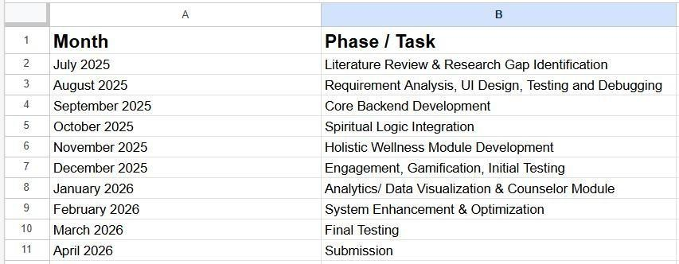

  - Role & Responsibilities:

- Chahat Modi: Chahat Modi: Research Gap Identification, Backend development, frontend design (Tkinter UI), database connectivity (MySQL), AI-based sentiment analysis implementation, feature integration (emotion reframing, shloka mapping, wellness tracking), and project documentation

CONCLUSION

The BhagvadMood Journal (SarathiApp) serves as a much-needed digital solution to the longstanding problem of generic and culturally detached mental health tools. By providing a transparent, offline platform, the system ensures high data privacy while reducing the risk of crisis moments going undetected through priority regex-based safety protocols.
This minor project demonstrates the practical application of Computer Science and Engineering principles—specifically Natural Language Processing (NLP) and Database Management—in solving real-world wellness issues. It fills a critical research gap by moving beyond simple rule-based systems to provide culturally resonant insights that contextualize emotional states via Bhagavad Gita wisdom.
The system has strong potential for future enhancements, including:

- LLM-Powered Conversational Support: Integrating agents like Gemini for dynamic, empathetic user interactions.
- Cloud Synchronization: Enabling cross-platform integration and secure clinician access.
- Advanced Mood Prediction: Utilizing deep learning models for context-aware emotional detection.
- Wearable Integration: Capturing physical stress data from smart devices for a more holistic health analysis.
By blending ancient tradition with modern technology, this project provides a scalable and interactive foundation for holistic personal growth and emotional resilie

References

- https://www.researchgate.net/publication/391802393_Sentiment_Analysis_for_Menta l_Health_Challenges_and_Opportunities
- https://github.com/Jhalak19y/MindLens_AI_Mental_Health_Analyzer
- https://research- archive.org/index.php/rars/preprint/view/1632?utm_source=chatgpt.com
- https://en.wikipedia.org/wiki/Global_mental_health?utm_source=chatgpt.com
- Bhatia, S. C., & Bhatia, S. K. (2005). The Bhagavad Gita: A precursor to modern psychotherapy? This paper explores how the dialogue between Krishna and Arjuna mirrors modern counseling.
- IJPsy-41-5.pdf Mental Health in Ancient India & Its Relevance to Modern Psychiatry. Focuses Historical context of mental wellness in India.
- Wysa: Everyday Mental Health, "Wysa: AI-driven mental health support," 2026. [Online]. Available: https://www.wysa.io/

